Finance Problem Set 1
Name
Institutional Affiliation(s)

Question One
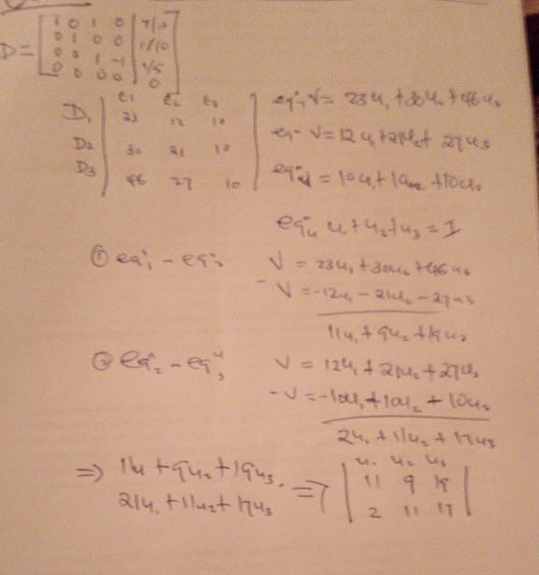

(a). The market is incomplete because in a complete market there is no transaction cost but in the real market there is transaction cost.
b. Yes, the risk -free payable is attainable since there is no transaction cost involved in an incomplete market
c.The law of one price usually call for a fair value and in this scenario the law is attained since the price is equal to the economic value.
d. The price permits arbitrage since the law of one price is temporary
Question Two
- . Arbitrage free condition is a situation where there is no mispricing. That is, asset price is similar in all markets
- P(Sr=u)=P₁ , P(Sr=d)=1-P
S₁ (0)=5, S₂(0)=10 , r=0-2
S₁ (1, w₁ )=2, S₁(1, w₂)=6 , S₁(1,w₃)=7
S1 |  | S2 |  |  | P/0 | PV | PRICE
 | 7 |  | 15 | 8 | 2.64 | 2.2
5 | 6 | 10 | 8 | 2 | 0.66 | 0.55 | 3.85
 | 2 |  | 0 | 4 | 1.32 | 1.1

Question three

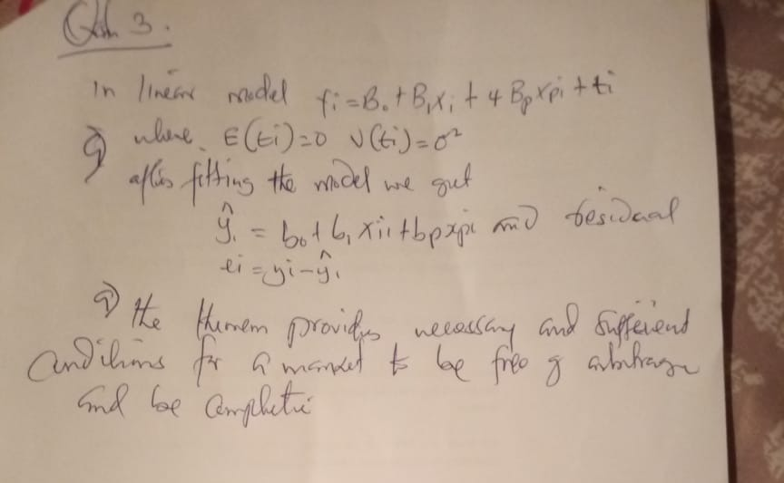
Question four

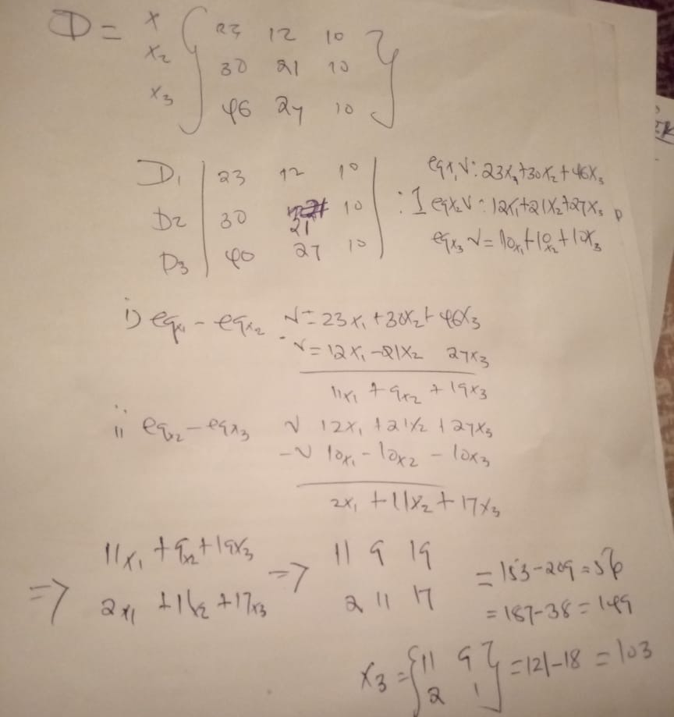
(a). The state security allows construction of any payoff pattern. Hence, the market is complete because there are no new securities to be constructed
(b) Risk-free payoff is attained because the market is arbitrage free
(c). Since the market is arbitrage free the law of one price is not attained
(d) Complete market implies that any market pattern can be constructed arbitrage free. Here patterns are properly priced. Hence, there is no arbitrage opportunities. Therefore, the market does not permit arbitrage
(e) Equilibrium price of security with payoff of X=[1,-1,0,0]
